Chapter 7, Problem 63.

Obtain v(t) and i(t) in the circuit of Fig. 7.128.

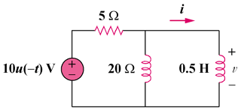

Figure 7.128
For Prob. 7.63.

